Create a class name Demo, create a file.

create a class and write the information by using File Writer.

create a class and write the information by using Buffered Writer.

Create a class and write the information by using Print Writer.

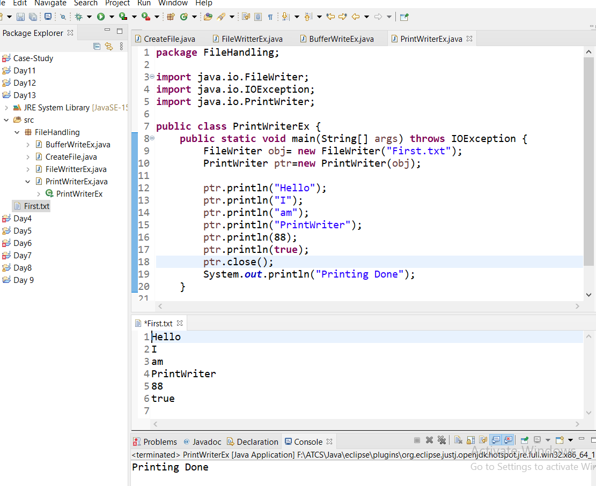

create a class and read the information by using File Reader.

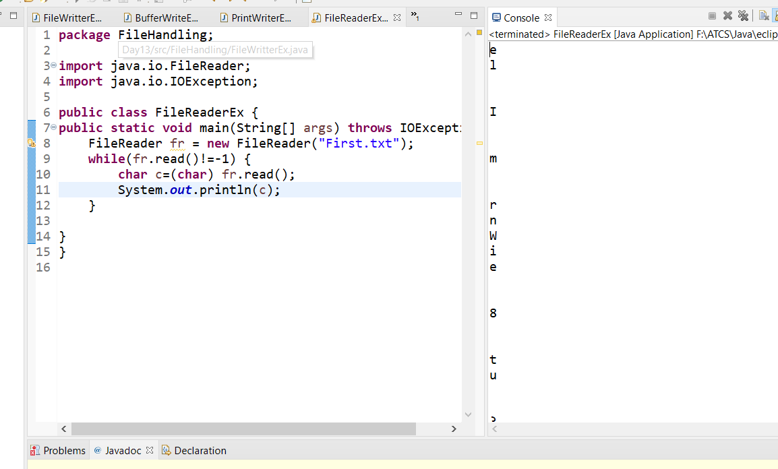

create a class and read the information by using Buffered Reader.

create a class LinkedList apply with generics.

